**P4 - Implement a working event driven application to meet defined requirements**

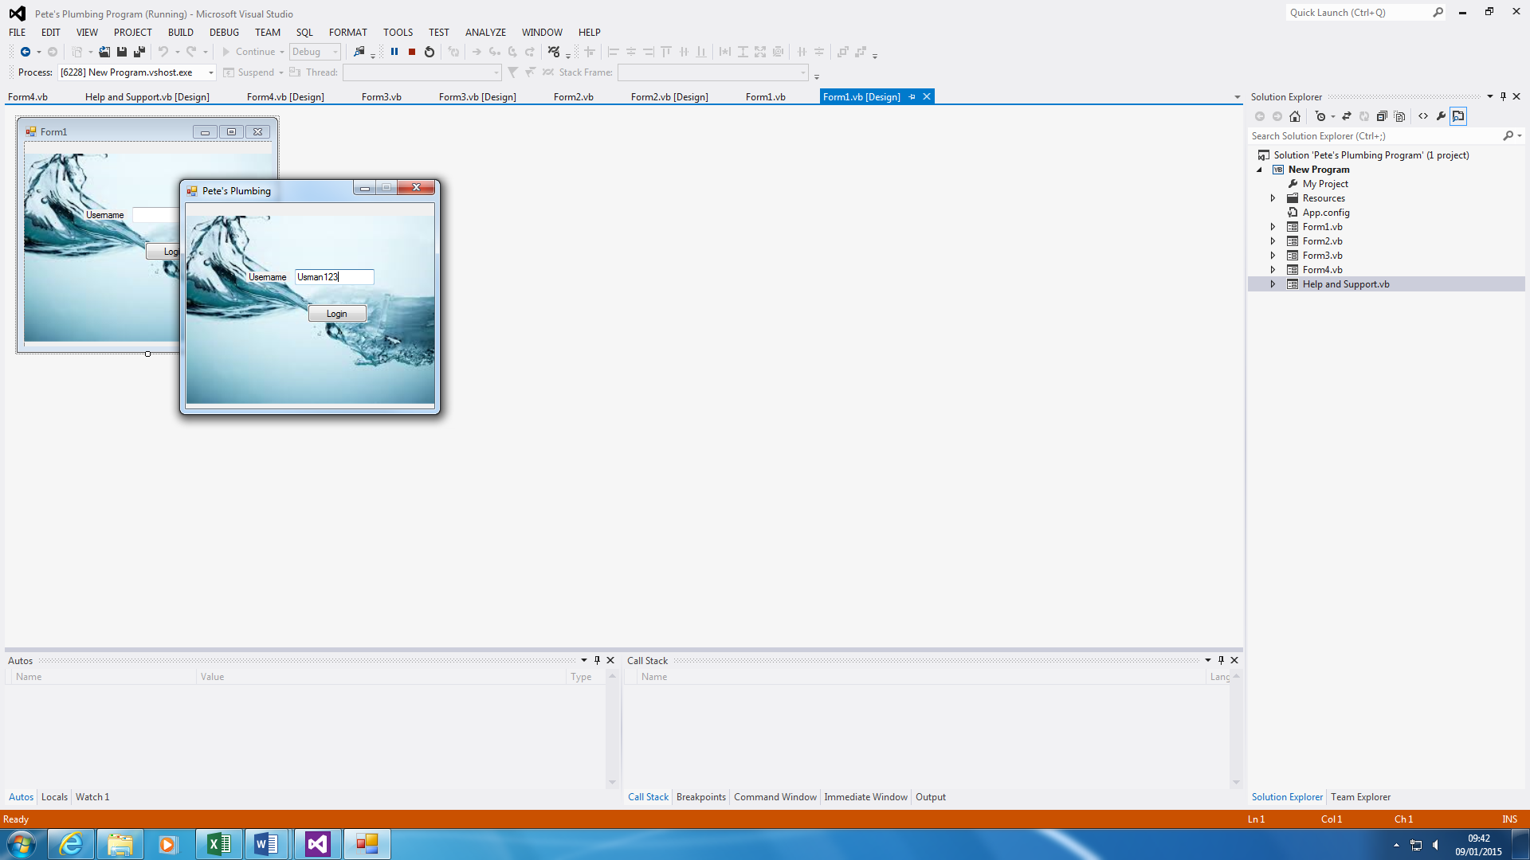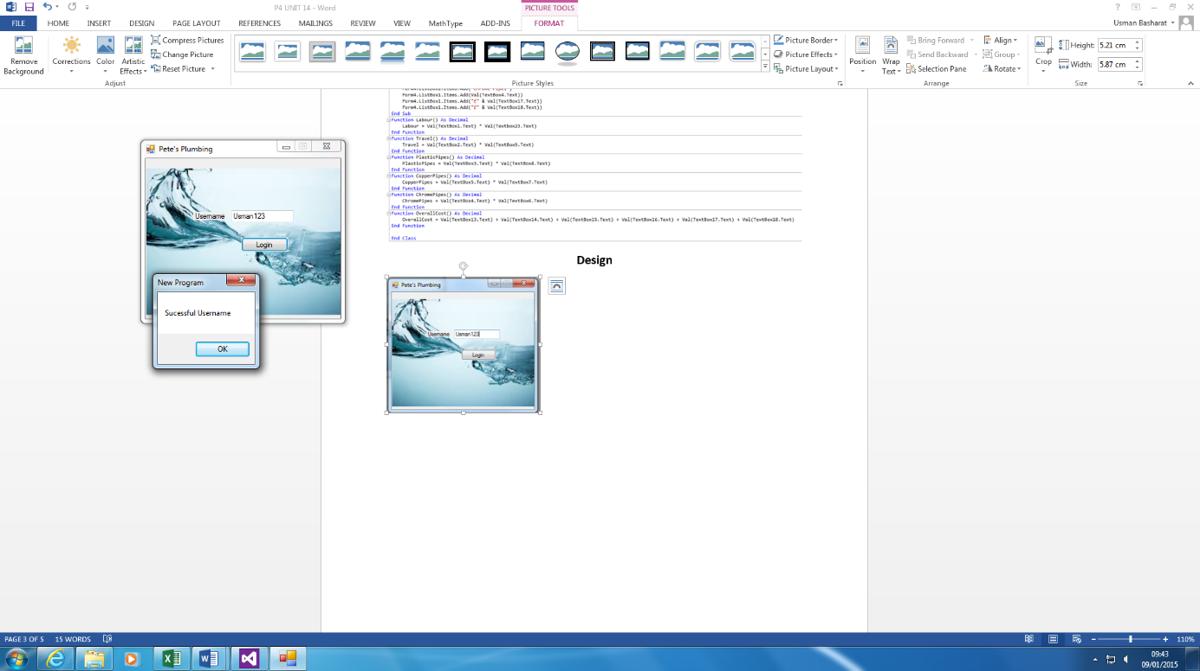**Login Screen**

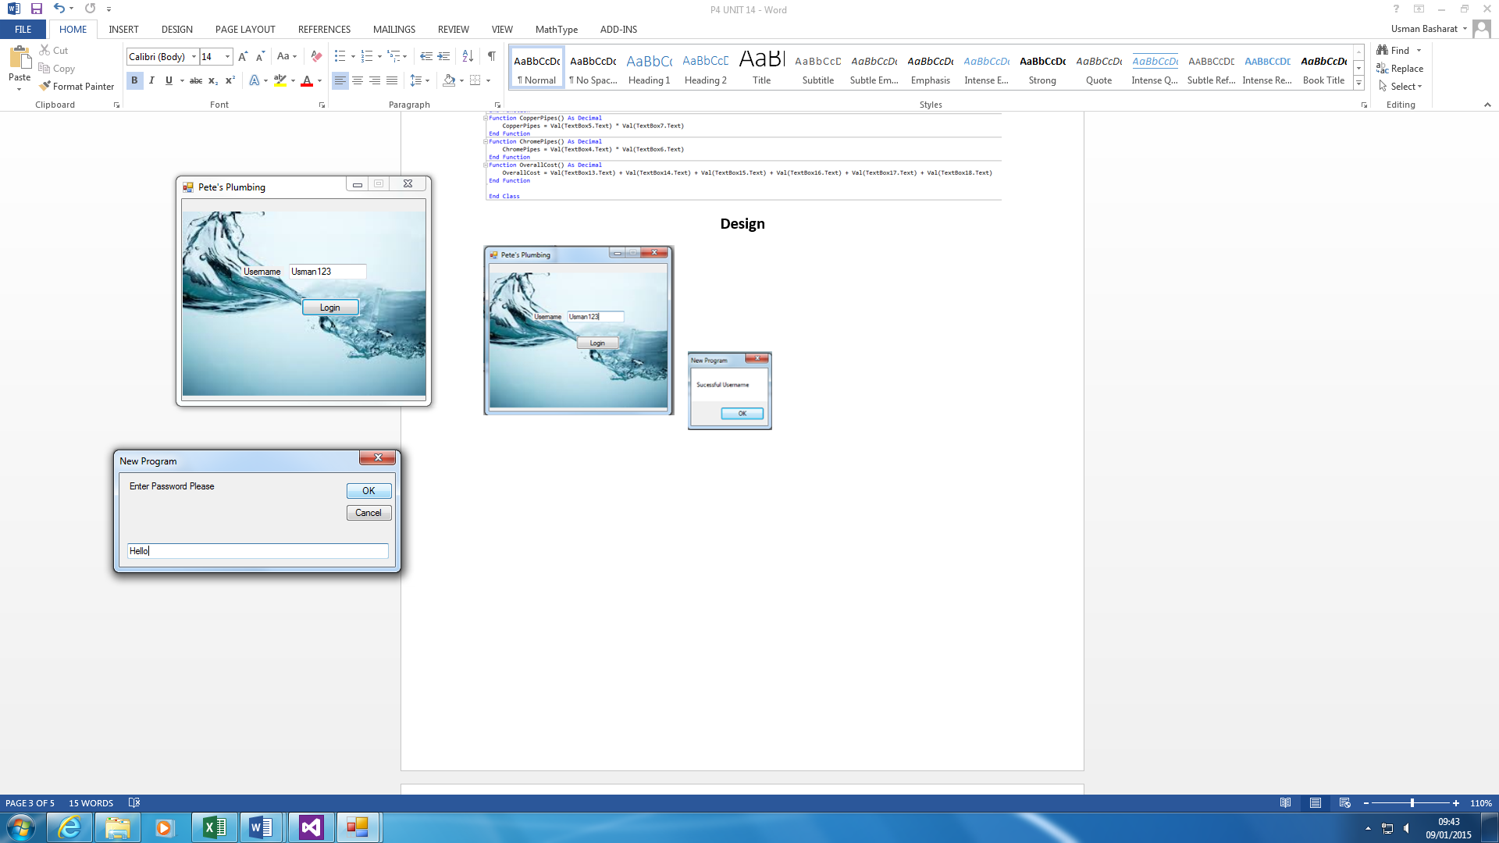

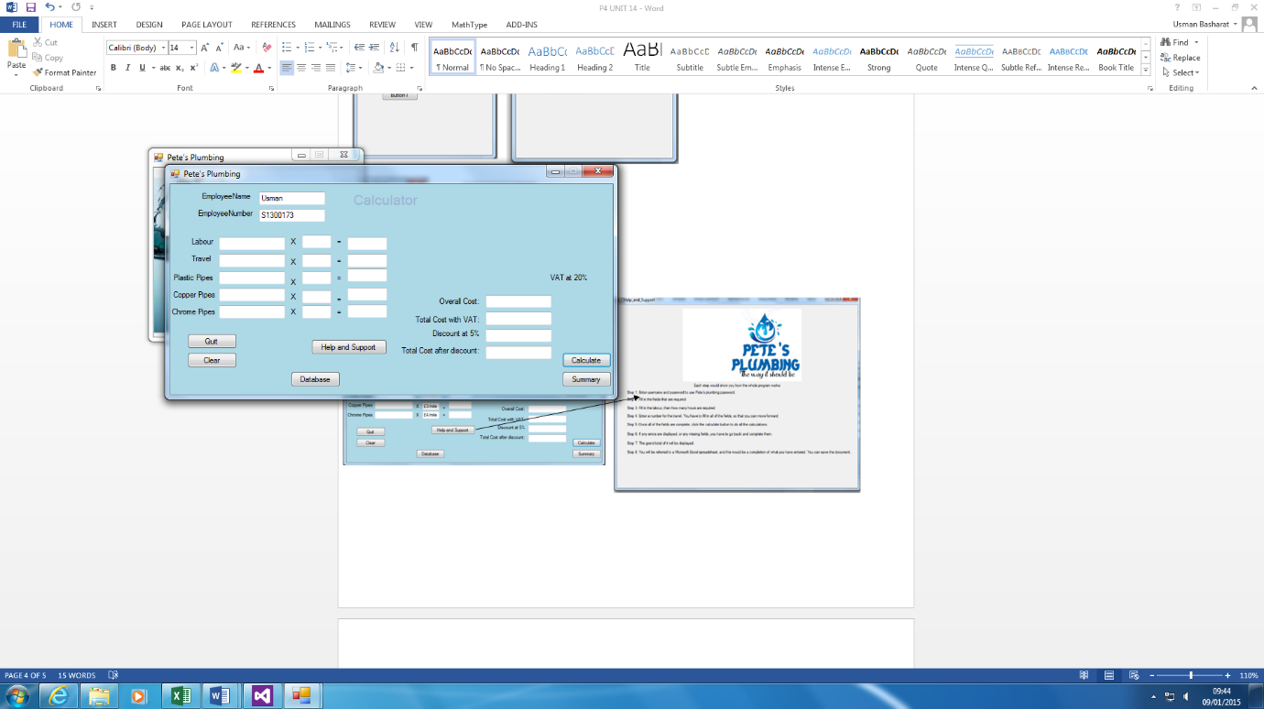

This is the login screen. As you can see, the username is typed in, and that needs to be correct in order to move on to the password. As you can see the code below, it shows how it works. The user will enter the username, “Usman123”, and password has to be correct in order show Form2.

**Login Screen CODE**

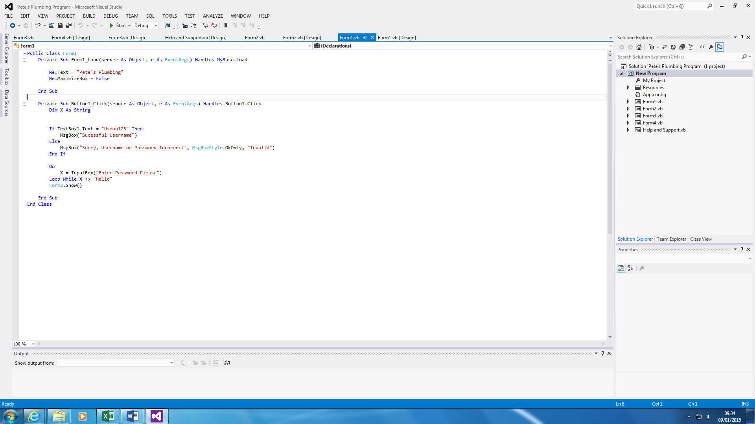

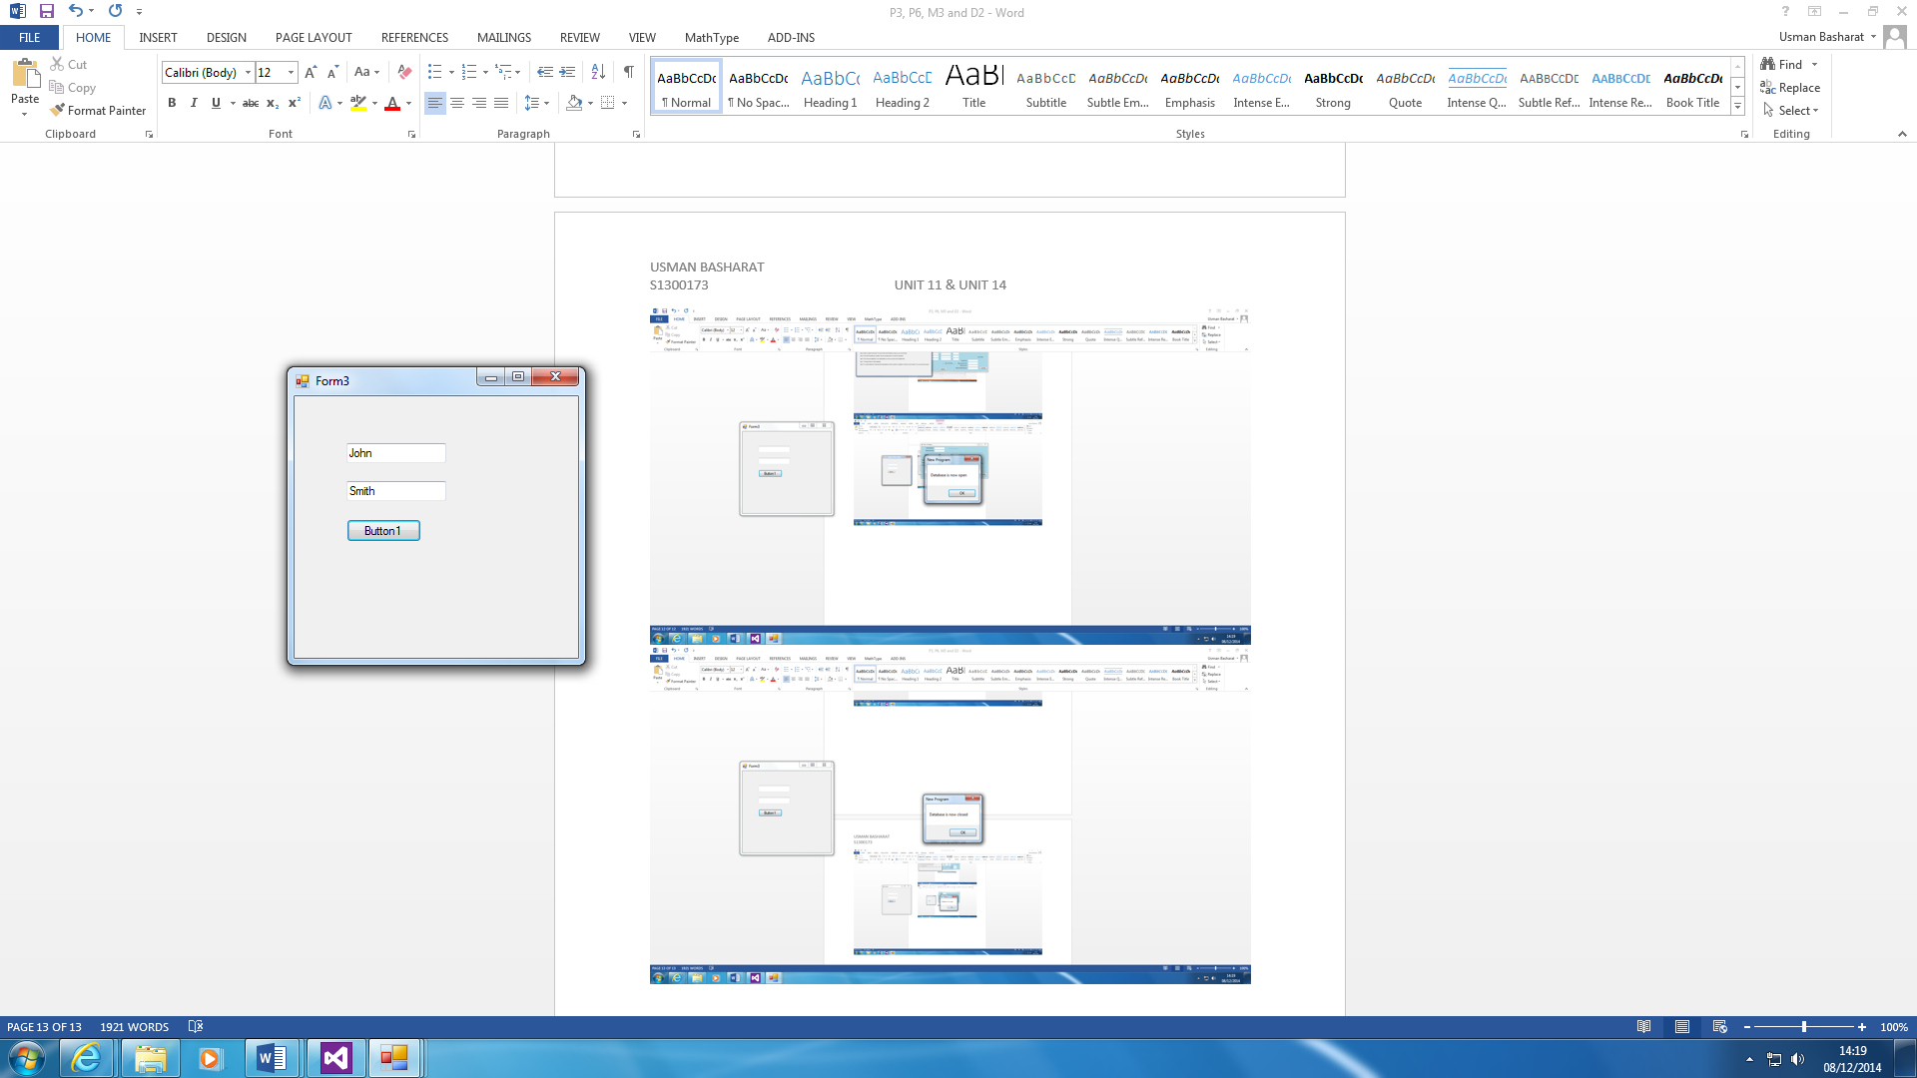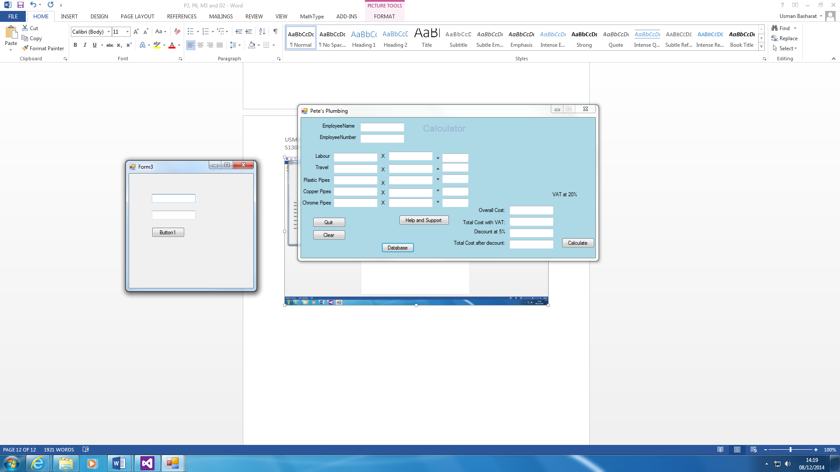**Database**

This database is made that can be used for several other reasons, but I chose to do this because it shows the connection between the two. The code instructs how it is complete. Firstly, the user needs to click the button. Once this is complete, the information is brought from the database. It gets the information, and it fills it in within the two boxes. It can be used for the Login Screen as well. Therefore, they are many benefits for its use.

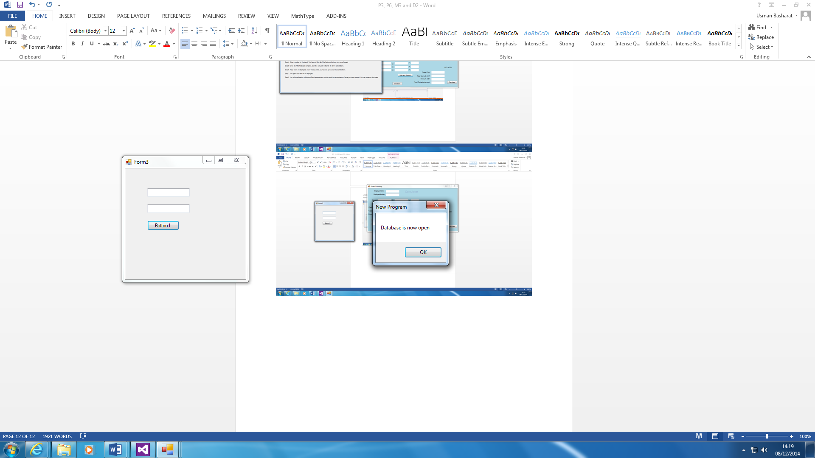

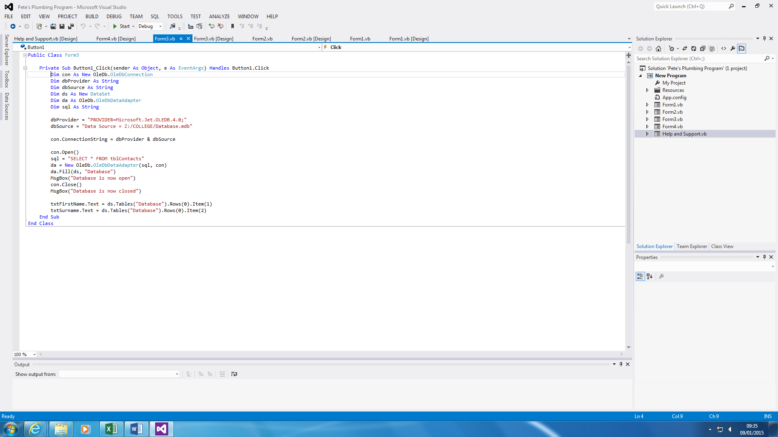

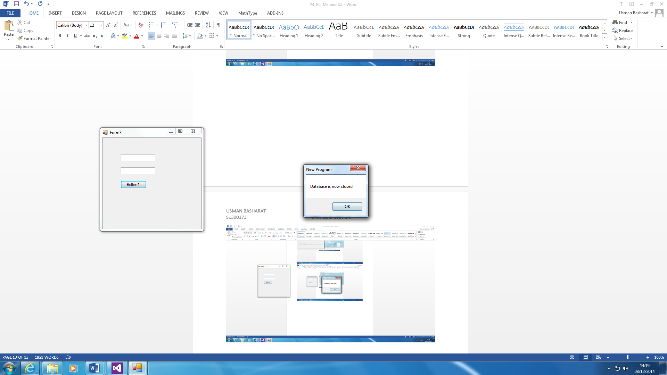

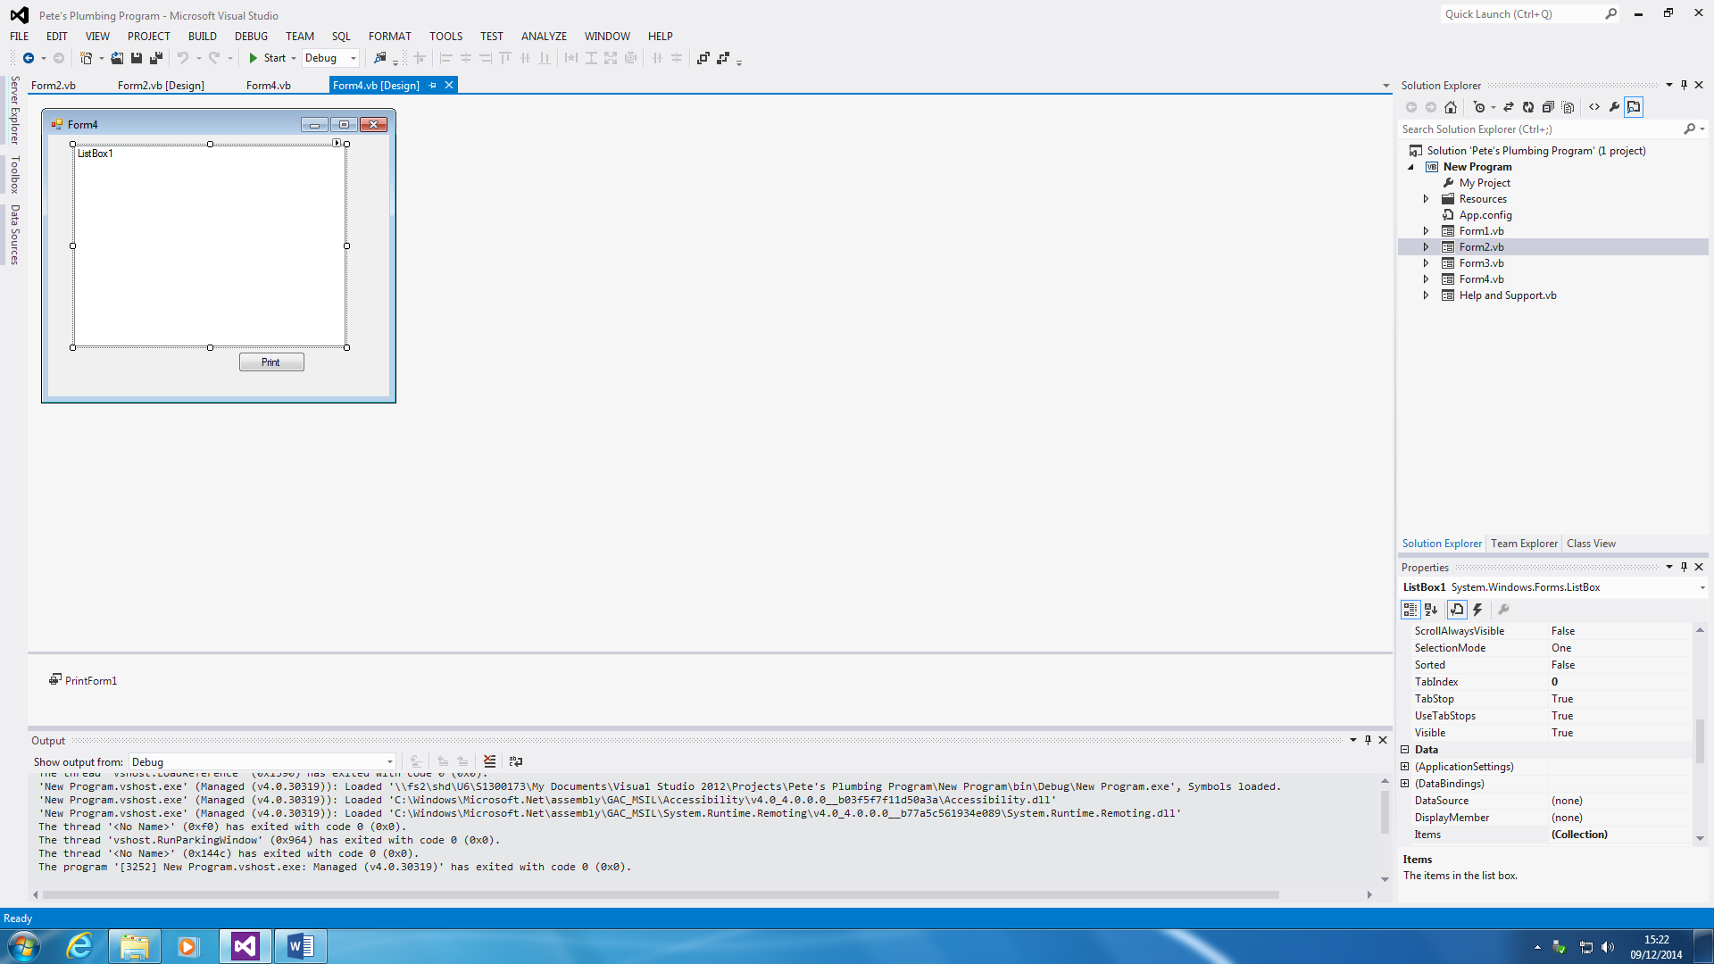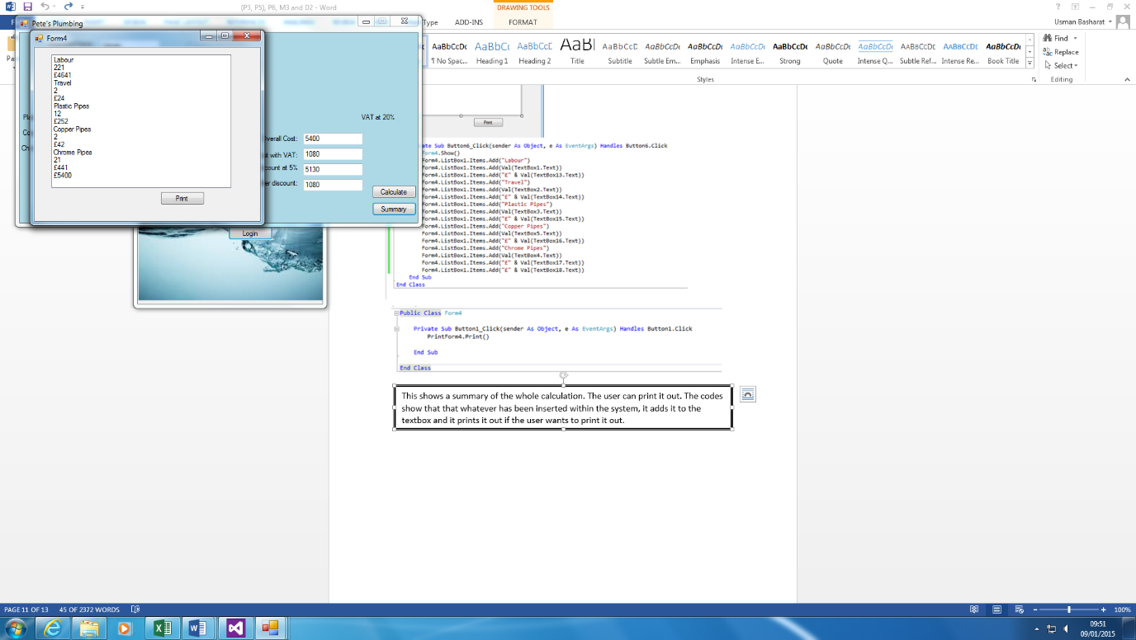**Printing/Summary**

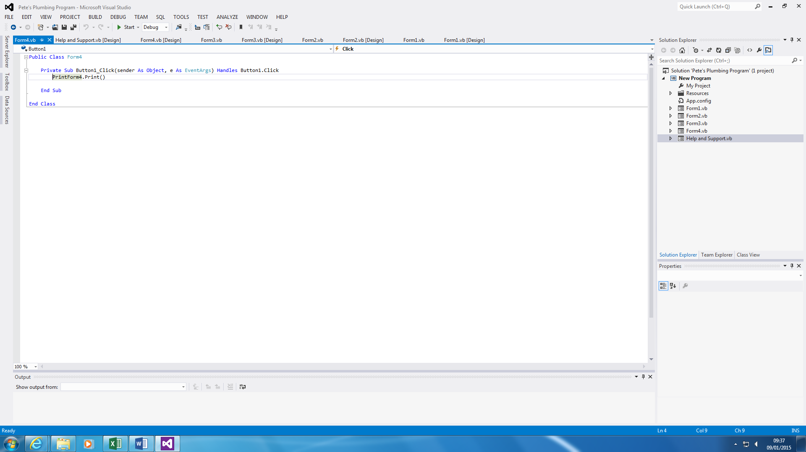

This shows a summary of the whole calculation. The user can print it out. The code above shows that whatever has been inserted within the system, it adds it to the textbox and it prints it out if the user wants to print it out.

**Main Form CODE**

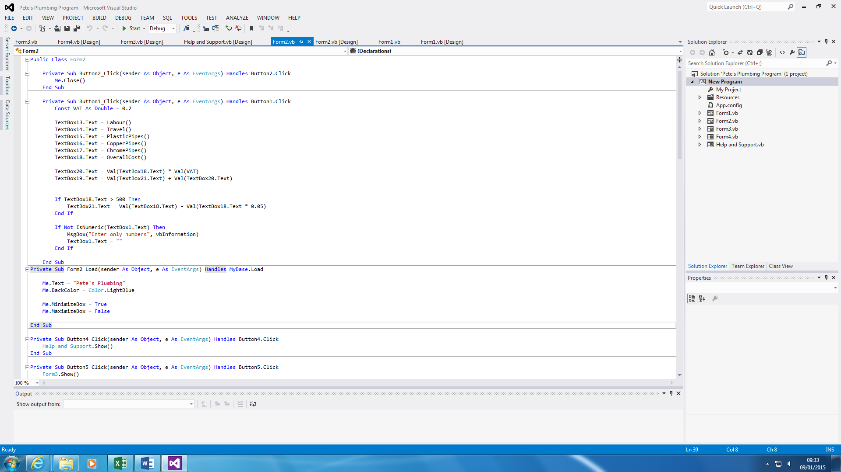

Figure 1.1

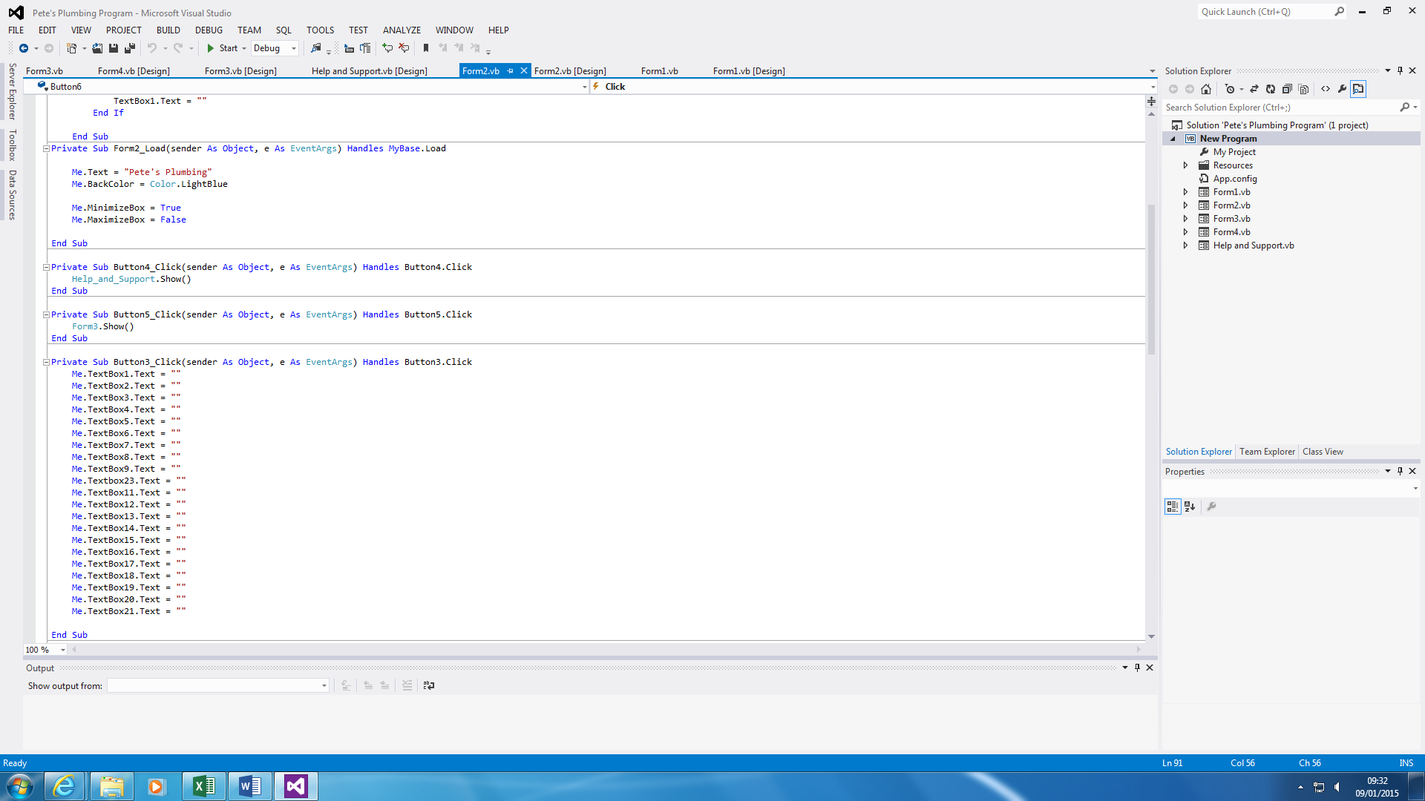

Figure 1.2

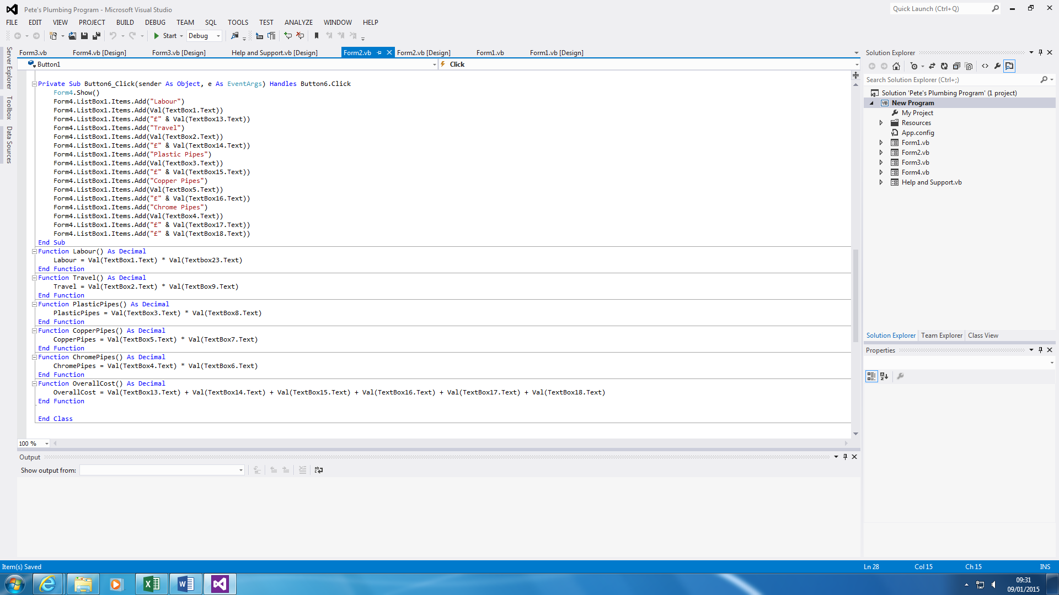

Figure 1.3

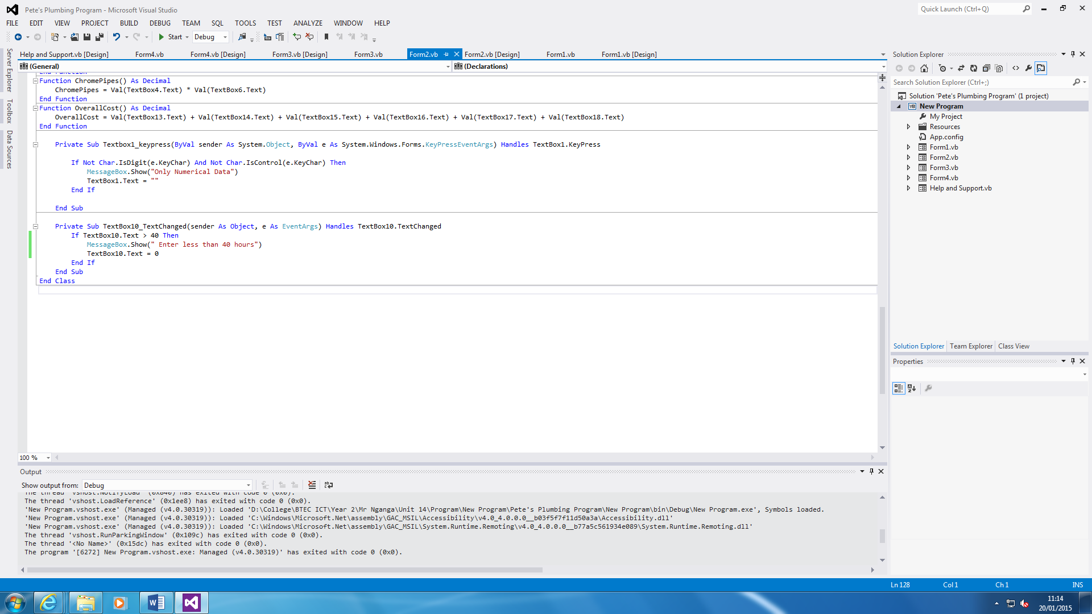

They are three pictures to show three parts of the whole code. Figure 1.1 shows us all the calculations and if anyone types in any negative, or anything apart from a number, it will show an error box; it will detect; and clear the box. Figure 1.2 shows us the customisations of the Main Form and once the clearing button is clicked, it clears all the textboxes. Figure 1.3 shows the summary code and the functions that I have used to put it in as a variable.

The last code shows that if Textbox1 has entered not a numerical data, a message would appear. The second one shows a limit to what the user can enter. This means, if the user wants to enter 45 hours within Hourly Rate, a message would appear saying, “Enter less than 40 hours”.



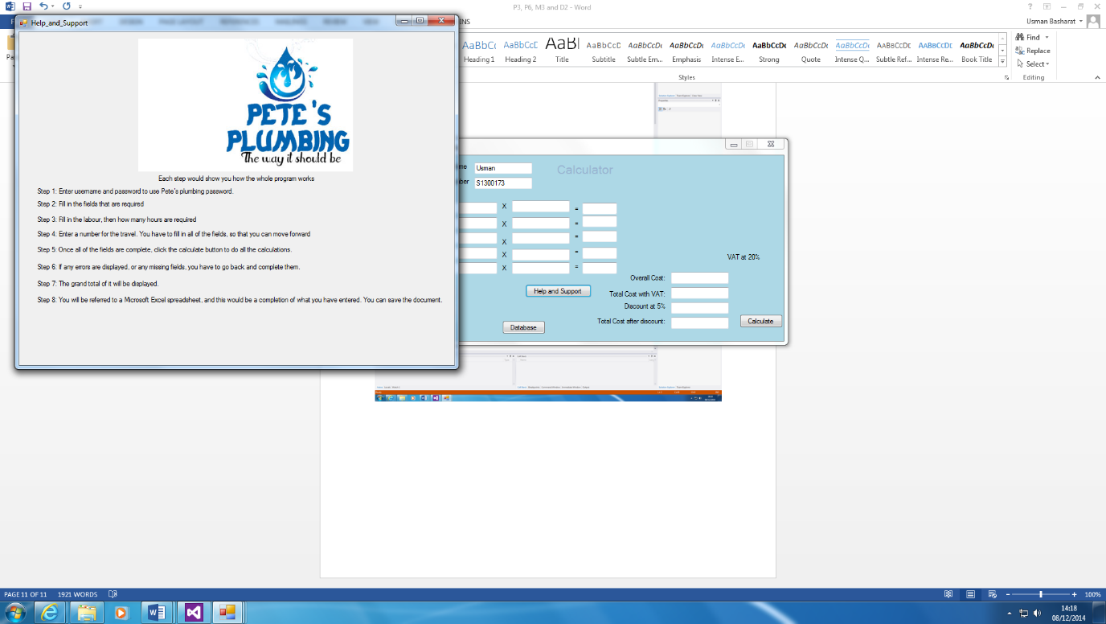**Help and Suppor****t**

Help and Support button is easy. If the user has any problems with it, he/she can use the systematic guide of how the program is run. All you do is press the button and another sheet pops up to show the systematic guide.



**Clearing**

Clearing button shows us that you can restart the whole calculations if there is any errors. The code below shows that all of them are cleared.

